|  |
| --- |
| **Ex.No 3 DML Commands – INSERT, SELECT, UPDATE, DELETE** |
|  |

**Questions**:

1. Populate all the five tables with your own data.

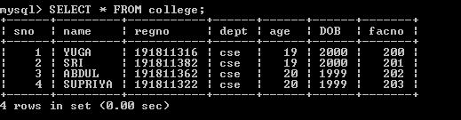

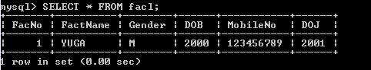

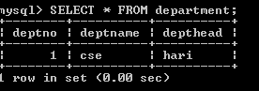

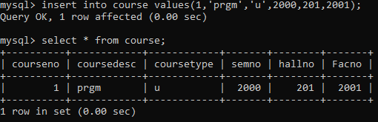

2)Update the value of student name whose register number is ‘191711342’



3)Delete the record in the table FACULTY, who resigned her job.



4)Modify the date of birth for the faculty whose name is 'RAM' with a value ‘1983-05-01’

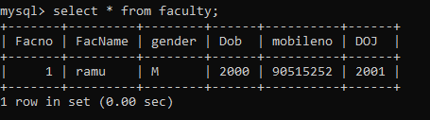

5)Remove all faculty who are having over 65 years.

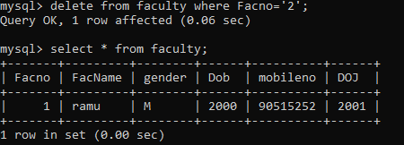

6)View all the records from the five tables.

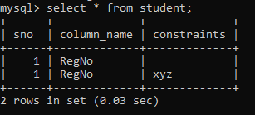

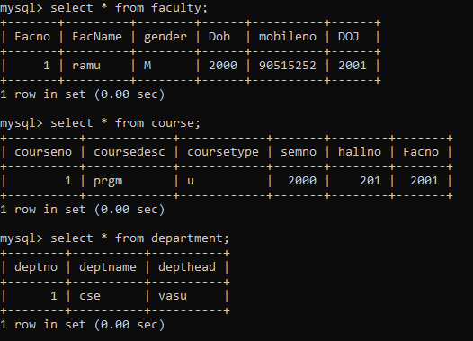

**Ex.No 4 SELECT with various clause – WHERE, pattern matching**

**Questions:**

1.The student counsellor wanted to display the registration number, student name and date of birth for all the students.

2.The controller of examinations wanted to list all the female students

3.Who are the boy students registered for course with the course number “C001“

4.Display all faculty details joined before “November 2014”

5.Display all the courses not allotted to halls

6.List the students whose name ends with the substring “ma”

7.Display all students whose name contains the substring “ma”

8.Find all the students who are located in cities having “Sal” as substring

9.Display the students whose names do not contain six letters.

10.Find all the students whose names contains “th”

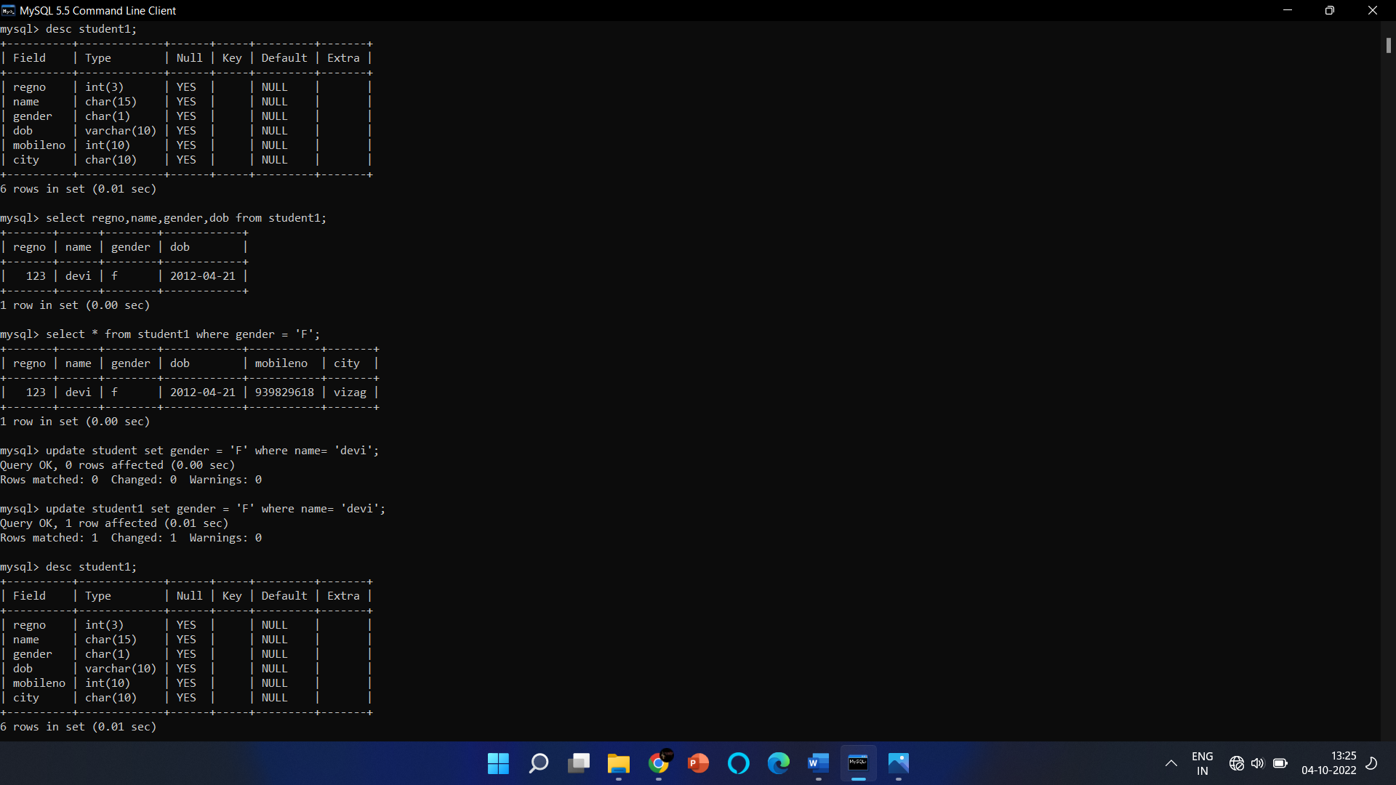

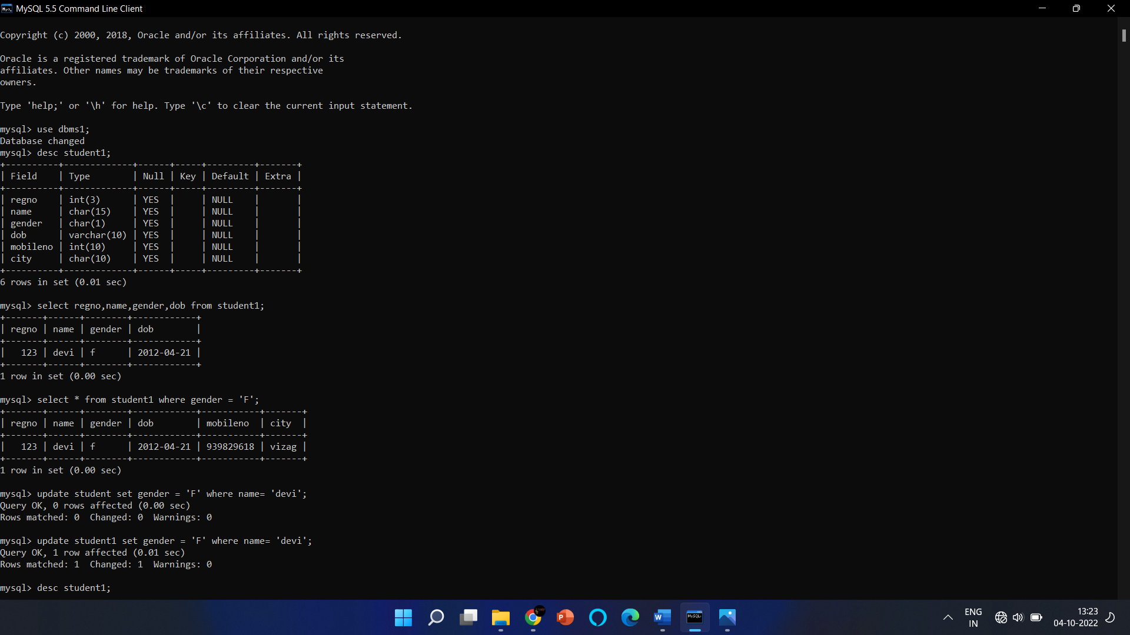

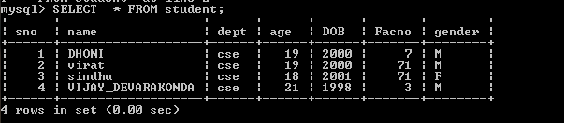

**Ex. No. : 5**

**SELECT with various clause – BETWEEN, IN, Aggregate function**

**IN & BETWEEN**

1. List the type of the courses “DBMS” and “ds”
2. The instructor wants to know the CourseNos whose scores are in the range 50

to 80

**AGGREGATE**

1.Find the average mark of “C2”.

2.List the maximum, minimum mark for “C1”

3.List the no of faculties in each department

4.List the name of the courses and average mark of each courses.

5.Calculate the sum of all the scores.

6.How many students are registered for each course

7.Display the sum of salaries in each department.

